We’ve got this!

Developing and selling your pitch

Sprint #2 expectations

* ● Ideal Sprint presentation
  + ○ Clear narrative that articulates why the market needs this product
  + ○ Working demo or high-fidelity prototype that feels “real”
  + ○ Validation should include 1) actual customer(s) and 2) BigCo stakeholders as internal “customer” of your work
* ● That said, you should deliver your best work output:
  + ○ Given organizational dynamics you’ve discovered
  + ○ With evidence of a high degree of effort
* ● For Sprint 2:
  + Describe technical plan and/or architecture: what you will ***build*** and what you will ***use*** (APIs, services, platforms)

|  |  |  |  |  |
| --- | --- | --- | --- | --- |
| Task | Status | Assigned To | Timeline | Notes |
| Sprint 2 | | |  |  |
| Set up time with Anthony | Completed | Mansi | At 10 AM tom |  |
| Hi-Fi Prototype | Completed | Mansi & Alan | By 12:30 PM tom |  |
| Market analysis, Value proposition | Completed | Mansi & Alan | By 12 PM tom |  |
| Experimentation (Surveys, Persona, etc) | Survey - completed | Survey and Persona creation: FJ  Sending - Everyone | Send out survey by 7PM tonight |  |
| Completed | By 10 AM tom |  |
| Data Collection, Cleaning | In progress | Christian, Harry, FJ | By 12:30 PM tom | <https://www.kaggle.com/shuyangli94/food-com-recipes-and-user-interactions>  <https://docs.google.com/document/d/1R4ApSgj07DoMsagX99I49lPCbZu1qUC2NgDq_8aFYTc/edit?usp=sharing> |
| Preliminary recommendation system | In progress | Dong, James | By 2:30 PM tom | Should we link to WholeFoods? |
| Presentation (including figuring out stats such as how much food waste reduced using our solution) | Completed | Everyone | By 2:30 PM tom |  |

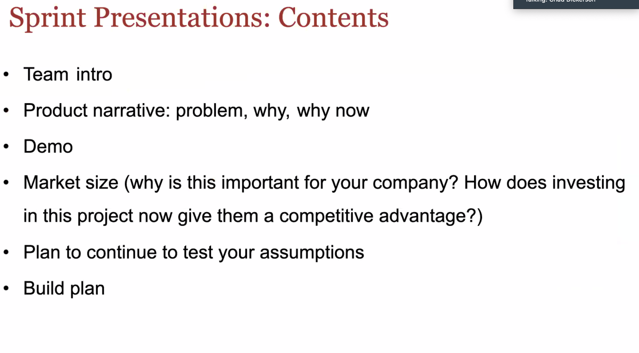

|  |  |  |
| --- | --- | --- |
| Sprint 3 | | |
| Website UI | Open |  |
| Website Backend | Open |  |
| Recommendation System | Open |  |
| Integration | Open |  |

**Next Steps:**

Expectations for final presentations on May 5, 2020

Be sure to read this so you understand the expectations for the final product as you go through the sprints!

Context of presentation: meeting with the CEO

The final presentation should be appropriate for this context: Imagine that your company’s CEO runs a biweekly executive team meeting. Your VP is impressed with the team’s progress and has secured a 4 minute slot for you. The next meeting is on Tuesday, May 5th at 3pm (time of final presentations). Create a presentation appropriate for this audience and setting based on everything you’ve learned in the class.

Content that should be included in their presentations

Team / Intro

Product narrative

Why / Why now / Vision

Validation / Strategy

Technology

Super hi-fi demo. A “super hi-fi demo” means a product should ideally include:

Real technology: An app, web site, and/or hardware device that any person could interact with. Teams can use public APIs or simulate web site changes by using technologies like Google Chrome plug-ins to change aspects of their BigCo advisors’ web sites. Videos, wireframes, and/or slides do not constitute a strong demo.

Real users: A person can use the demo on a phone, web browser, and (in some cases) using prototype hardware. If the demo is primarily algorithmic and therefore doesn’t have a frontend component, think of the user as a software developer or designer integrating the output of your algorithm into a product. For example, the user interface in your demo could be a well-documented API delivered via HTTP. In that case, you would demo how this user would interact with your API and describe the technology and data behind it.

Real data: Actual data is preferred. When actual data isn’t available we expect students to generate realistic “fake” data or use public data sources

Presentation format and logistics

Length: 4 minutes

Keep slides simple (Ideal: 1 image per slide / 1 text line per slide)

Must use mics while presenting.

Evaluation and grading

Students will be evaluated and graded on:

how well they weave this content together and present the material

how well they utilize specific skills of their teams (e.g. teams with more engineers will be expected to build more technically-sophisticated demos)

how they approach and surmount the inevitable obstacles they find in working with their BigCo advisors.

progress made from beginning of semester in late January through and after each of the three Sprints (Feb 13/14, March 19/20, April 23/24) leading up to the final presentation on May 2